**1. Purpose** **2**

**1.1. Intended Audience** **2**

1.2. Intended Use 2

1.3. Scope 2

1.4. Definitions and Acronyms 2

**2. Overall System Description** **3**

2.1. Use Case Diagrams 3

2.2. System Architecture 4

**2.3. Functional Requirements** **5**

2.3.1. Startup and Main Menu

2.3.2. Remote Access

2.3.3. Authentication Services 5

**3. Software Architecture** **6**

3.1. Static Software Architecture 6

**IoT - Library Book Reservation and Collection System - System / Software Requirements Specification (SRS)** **1**

# 

# Purpose

## 1.1. Intended Audience

The target audience of this Library Book Reservation and Collection System are people who are keen on borrowing books from a public library.

## 1.2. Intended Use

The SRS defines the overall System Architecture and Requirements as well as the Software Architecture and Design. This document also contains the definition of the System Requirements which shall be used as the input for System Test cases and Software Unit Test cases.

## 1.3. Scope

Create a system where customers can loan and return books automatically from a library. Customers can also use an application on their mobile phone to remotely make a reservation online.

## 1.4. Definitions and Acronyms

|  |  |
| --- | --- |
| **Acronym** | **Description** |
| LED | Light Emitting Diode |
| LCD | Liquid Crystal Display |
| QR | Quick Response |
| RFID | Radio Frequency Identification |

# 2. Overall System Description

## 2.1. Use Case Diagrams

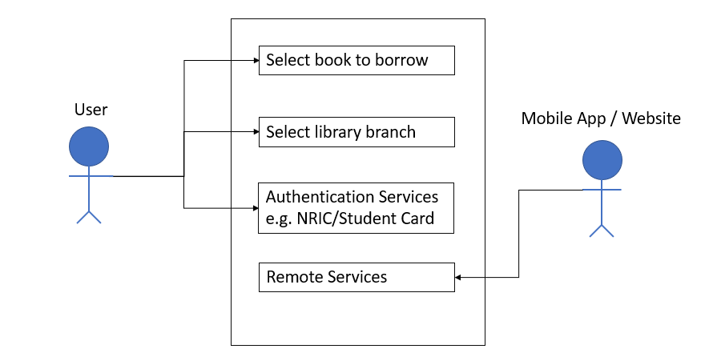

## 2.2. System Architecture

The System Architecture

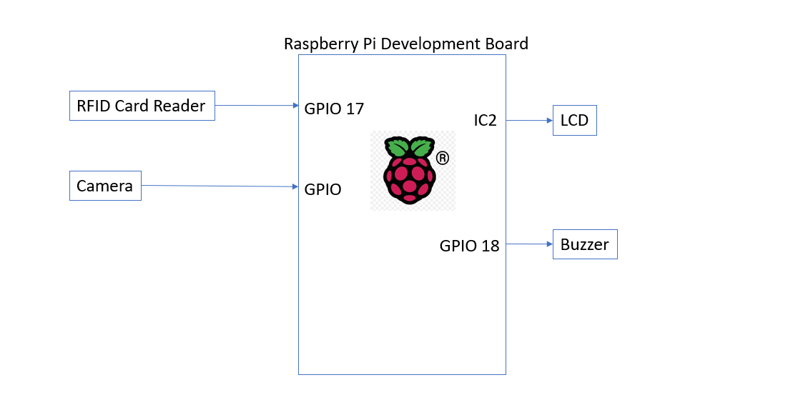

# 2.3. Functional Requirements

## 2.3.1. Startup and Main Menu

|  |  |
| --- | --- |
| REQ_ID | Requirements - Mobile App/Website |
| REQ-01 | Sign up Page on startup. Users are required to key in ‘Username’, ‘Password’, and ‘Confirm Password’. One more option, ‘Sign in’ will be on the page also for existing users. |
| REQ-02 | After Sign up, users will be redirected to a page to link their SP Student Card Barcode. The page will have an option, ‘Link SP Student Card to Account’. Once clicking on the option, Camera will pop up waiting to detect the barcode. Once barcode is detected, the data will be saved as a num value string to the account. |
| REQ-03 | If existing user signs in instead, they will be instantly redirected to the home page (stated in 1.4) |
| REQ-04 | After the barcode is detected and data is saved to account, users will be redirected to the home page of 3 options. ‘Borrow a book’, ‘Existing Reservations’, and ‘Check book loan period’. Even if the user is first time signing up or the user is already existing, this will be the landing (home) page by default. |
| REQ-05 | Once the user clicks on the ‘Borrow a book’ option, User will be redirected to a page with a list of library branches they can choose from. |
| REQ-06 | Upon clicking on a library branch, users will be redirected to the list of books they can choose from. Upon clicking a specific book, users will be redirected to a page with the book’s information and the option below, ‘Reserve book’. |

|  |  |
| --- | --- |
| **REQ_ID** | **Requirements** |
| REQ-07 | Upon clicking on ‘reserve book’, the flowchart defined in figure x shall be implemented. |

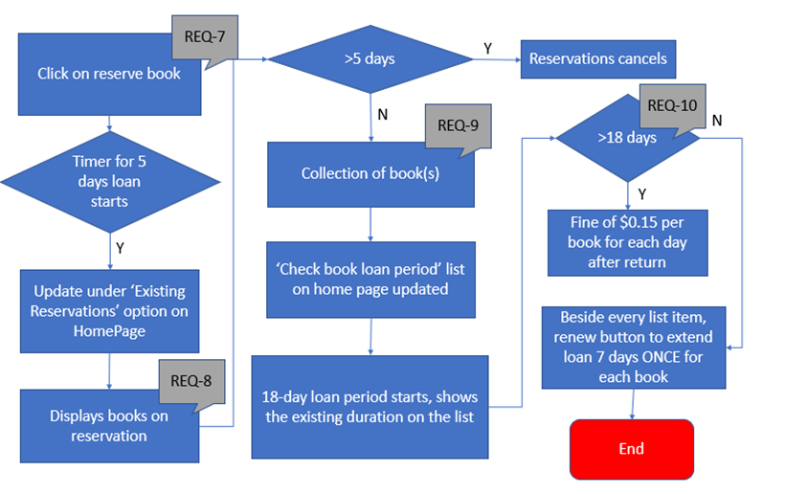

Figure x

## 2.3.2. Remote Access

The library system supports “Remote Access” to monitor the system functions.

|  |  |
| --- | --- |
| **REQ_ID** | **Requirements** |
| REQ-11 | The user shall be able to login to the IP address of the library system to view a webpage/access a mobile app. |
| REQ-12 | The mobile app allows the user to monitor the following,  · Number of book reservations  · Number of books not collected  · Outstanding fines  · Duration of borrowed books |
| REQ-13 | The mobile app allows the user to control the following,  · The requirements defined from REQ-1 to REQ-10 |

## 

## 

## 

## 

## 2.3.3. Authentication Services

For commercial variants of the Library Book Reservation and collection system, an added feature is to authenticate the user details to use the system via a barcode reader before receiving the books reserved

|  |  |
| --- | --- |
| **REQ_ID** | **Requirements** |
| REQ-14 | For the library book reservation and collection with the barcode reader, upon Power On the LCD shall display the following  Line 1 = “Scan barcode to receive reserved books” |
| REQ-15 | If the barcode reader detects an NRIC/SP Student card that has no outstanding fines, then the system shall display the main menu defined in REQ-4. |
| REQ-16 | If the barcode reader detects an NRIC/SP Student Card that has outstanding fines, it prompts user to pay fines before reserving books as defined in REQ-10 |
| REQ-17 | If the barcode reader detects an unregistered NRIC/SP Student Card, the following shall be implemented,  · LCD shall display the following.  Line 1 = “Invalid Card / User not registered”  · Buzzer will be activated based on the timing diagram below |

# 3. Software Architecture

## 3.1. Static Software Architecture

The Software Architecture defines the various Software Components that are developed to realize the implementation of the system requirements.

**Application Layer**

**Hardware Abstraction Layer (HAL)**